Water Sampler

Subject: Physics  Related Subjects: Newton’s Third Law, Center of Gravity, Circuits, Archimedes' principle | Grade Level(s): 2,3,4,56,8  Length of Lesson: | Type: Inquiry / Design / Project  Keywords:Buoyancy, balance, action-reaction, displacement, components, degrees of freedom, joints

Lesson Overview
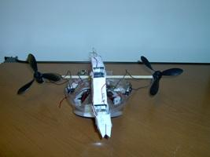
Students will create an airboat using plastic containers, motors and propellers that can operate semi-autonomously and as an ROV. Students will create two robot arms. One will be made from paper and controlled by strings

Lesson Focus
What is the central question or phenomenon being investigated? What problem are they trying to solve?

Lesson Objective(s) | - Students will create a boat, which will float and move in water.  - Students will create a paper robot arm that moves two parts  - Students will design boat to work independently or connected to a controller.  - Students will collect water samples

Lesson Timing

5 minutes | Introduce the Lesson
30 minutes | ...

Materials | - –¼” wood dowels  - –Toggle switches  - –Propellers  - –1.5v motors  - –Insulated wire  - –Single battery holders  - –Light plastic container or 1L bottles  - –Wire strippers  - –AA batteries  - –Hot Glue Gun  - –Glue sticks  - –Soldering Iron (optional)  - –Solder (optional)  - –pvc elbow  - –alligator clips  - –Saw  - –tape  - –fasteners
Instructor Prep | - Step 1
Related Resources | - List related lessons/ppts etc available from USC or outside, trusted orgs

Lesson Plan

Introduction

Boats have been around almost as long as humans have lived by the sea. In the late 1700’s, steamboats became among the first motor powered boats. The early 1900’s brought about the airboats, floats with motors elevated above water to create motion by circulating wind.
Boats like the Southern California Marine Institute’s SEA WATCH are used by scientist to collect water samples for experimentation.



Remotely operated vehicles (ROVs) are maneuverable underwater robots operated by a person. They are linked by a group of cables that carry electrical signals back and forth between the operator and the vehicle. The water sampler boat will serve operate as a boat and as an ROV.

Procedure
- –Cut and strip wires 4- 5inch wires and 2-3inch wires
- –Cut a 10-inch wood dowel (depending on boat frame). The ends of the stick should extend 3 inches beyond boat on each side
- –Glue pvc elbow to the back of the boat
- –Balance on pvc elbow and glue to boat frame
- –Insert one 5inch wire to one clip on motor
- –Insert another 5inch wire in other clip on motor
- –Tape or Solder wires to motors
- –Attach propeller to motor
- –Connect one of the free ends of motor wire to the back of an alligator clip. 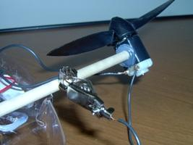
- – Connect the other the free ends of motor wire to the back of another alligator clip.
- –Tape or Solder red wire from battery holder to center hole in switch
- –Tape or Solder a 3 inch wire to either outside hole on switch
- –Glue motor to top of dowel of one dowel with propeller facing the front of boat frame tilted up at a 45º angle
- –Repeat for second motor and second switch

- –Glue switches to side
- –Glue battery holders to whichever part of boat frame, which maintains balance.
- –Place in shallow pool of water.
- –Check for stability and balance.
- –Connect alligator clips to wires and flip the switches
- –Change the connections of alligator wires and notice the difference. The boat either moves forward, backward, turns right or turns left depending on how you connect it.

Instructions for arm

- –Glue the Paper Robot Arm components sheet on to cardboard or cardstock paper
- –Carefully cut out the pieces
- –Bend along the long lines and form arm component pieces
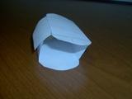
- –Using a thumb tack, poke holes in the component parts
- –Line up the holes from the humerus with holes on the radius/ulna
- –Insert fastener through both sides
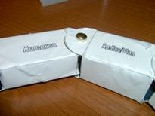
- –Line up the holes from the radius/ulna with holes on the carpal
- –Insert fastener through both sides
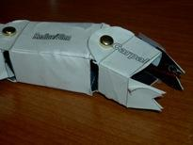
- –Cut a strip of foam board 4” x 2”
- –Cut another strip of foam board 3” x 2”
- –Cut two small pieces of foam board 1” x 2”
- –Create standing post by gluing the two small pieces of foam board on either side of 4” foam board

Side

front

- –Glue the standing post in the center of the 6” foam board

Side

front

- –Tape free side of humerus to the 1” from the top of the standing post
- –Tape a string to the far end of the radius/ulna
- –Tape a string to the far end of the carpal
- –Insert paper clip through top of the standing post
- –Bring free end of radius/ulna string through left side of paper clip
- –Bring free end of carpal string through right side of paper clip (see figure 6)
- –Tape free ends of both strings

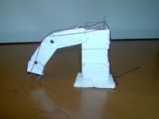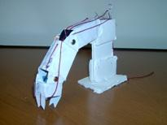

–Place the arm inside the boat and lightly tape
- –Place boat in water and balance arm so it floats
- –Glue arm in place

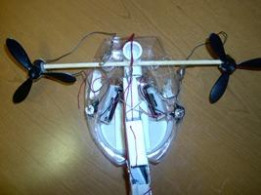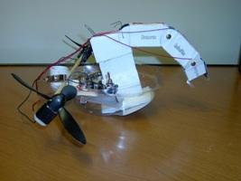

Wrap-up
- Students should be able to make necessary adjustments to make boat float, and travel in a straight line
- Students attach boat to teacher controller and gather samples

Lesson Background for Teachers

Explanation
Boat

Buoyancy, the ability to float, is the upward forces exerted by a fluid on a body in it. If the total area of the object that makes contact with the water is large enough, the object floats. The object must make room for its own volume by pushing aside, or displacing, an equivalent (or equal) volume of liquid. The object is exerting a downward force on the water and the water is therefore exerting a upward force on the object. Of course the floating object's weight comes into play also. The solid body floats when it has displaced just enough water to equal its own original weight.
Buoyancy is the loss in weight an object seems to undergo when placed in a liquid, as compared to its weight in air. Archimedes' principle states that an object fully or partly immersed in a liquid is buoyed upward by a force equal to the weight of the liquid displaced by that object. From this principle, he concluded that a floating object displaces an amount of liquid equal to its own weight.
By choosing a plastic body for the boat’s body, we can be sure the boat will be buoyant enough even when we add the motors, propellers, batteries and battery holder. Students can use a light plastic container (cover of a toy, or headphones package) or tape 2 – 1L bottles together.

A propellers provides thrust according to Newton's third law, the 'action and reaction' principle: that is, to every action there is an equal and opposite reaction. The propellers accelerate air in one direction, so the boat is subject to a force in the opposite direction. We mount the propeller so that the air is forced toward the back of the boat, thus pushing the boat forward.

The propellers will be mounted to extend out of the boat away from the sides and so the center of gravity of the boat frame so that it remains balanced in the water and doesn’t tip over.

Arm

To fully understand robots, you must realize that there are three challenges when it comes to designing robots:

- Making the actual robot part or parts so they do what you want
- A control system which cause the robot part or parts to move.
- A “brain” which says when, where, why and how the robot should move.

In the activity, we will be tackling the first two challenges. Our brain will be the one that controls the robot.

Like our bodies, robots have basic parts. We call these components. Your arm has three main components. The components are connected and are attached at a place which allows them to move. These places are called your joints. Starting from your shoulder, look at your arm. Part one is from your shoulder to your elbow. On you, this component is a bone called the humerus. Part two is from your elbow to your wrist. On you this component is made up of two bones called the radius and ulna. Part thee is from your wrist to your knuckle. This component is made up of bones called carpals. Each of your fingers have two more joints (the thumb has one more), but we won’t go into that in this activity. Some of your joints also allow side to side movement, but we won’t go into that in this activity either.

Your components move when muscles on one side of the joint pull the bone. For instance, your radius and ulna move toward you because of a muscle called the bicep. They move away from you because of muscles called the triceps.

In the paper robot arm, the components will be made out of paper. We will use string as our bicep-type muscle to pull the components up. We won’t have triceps-type muscles; gravity will pull the components back down. The arm will have a water collector attached to the hand.

Assembly
Students will mount robot on to arm and balance the water sampler so that it is stable. The water sampler will be able to run autonomously and with a controller

Safety Notes
- Students should use caution when using soldering iron and glue gun to avoid burns.
- Students should wear goggles.
- Students should use only shallow pool for boat.

